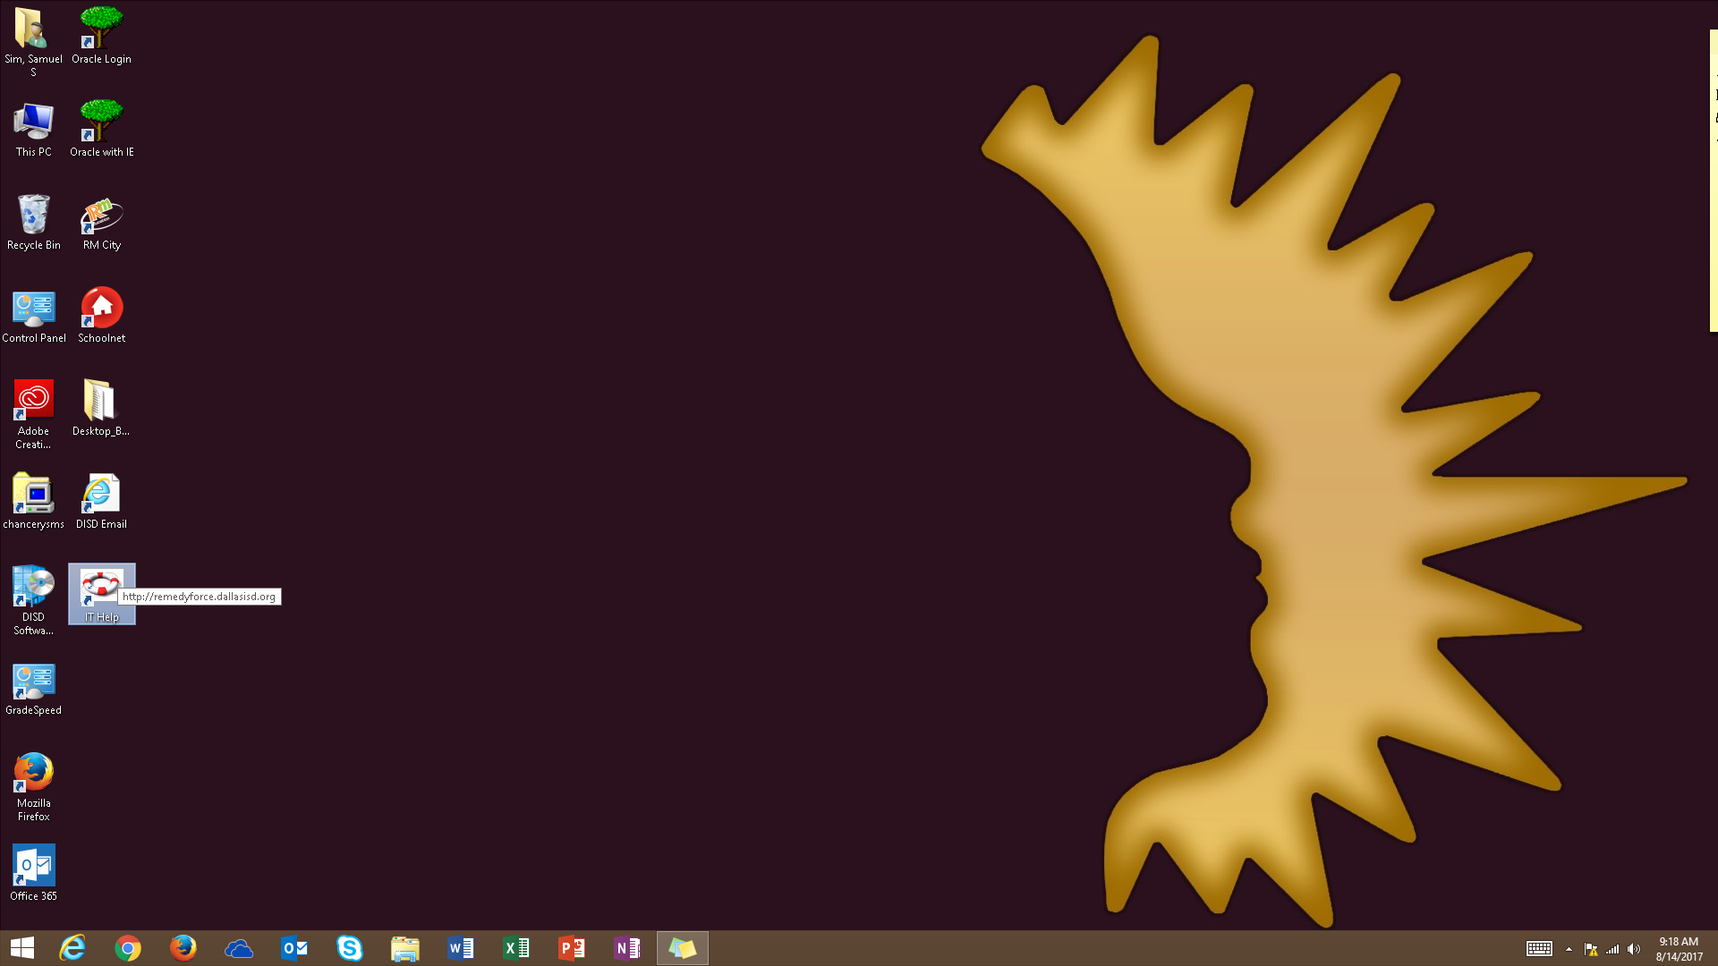
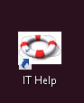
- Click on IT Help on the desktop (for issue and incident with technology).

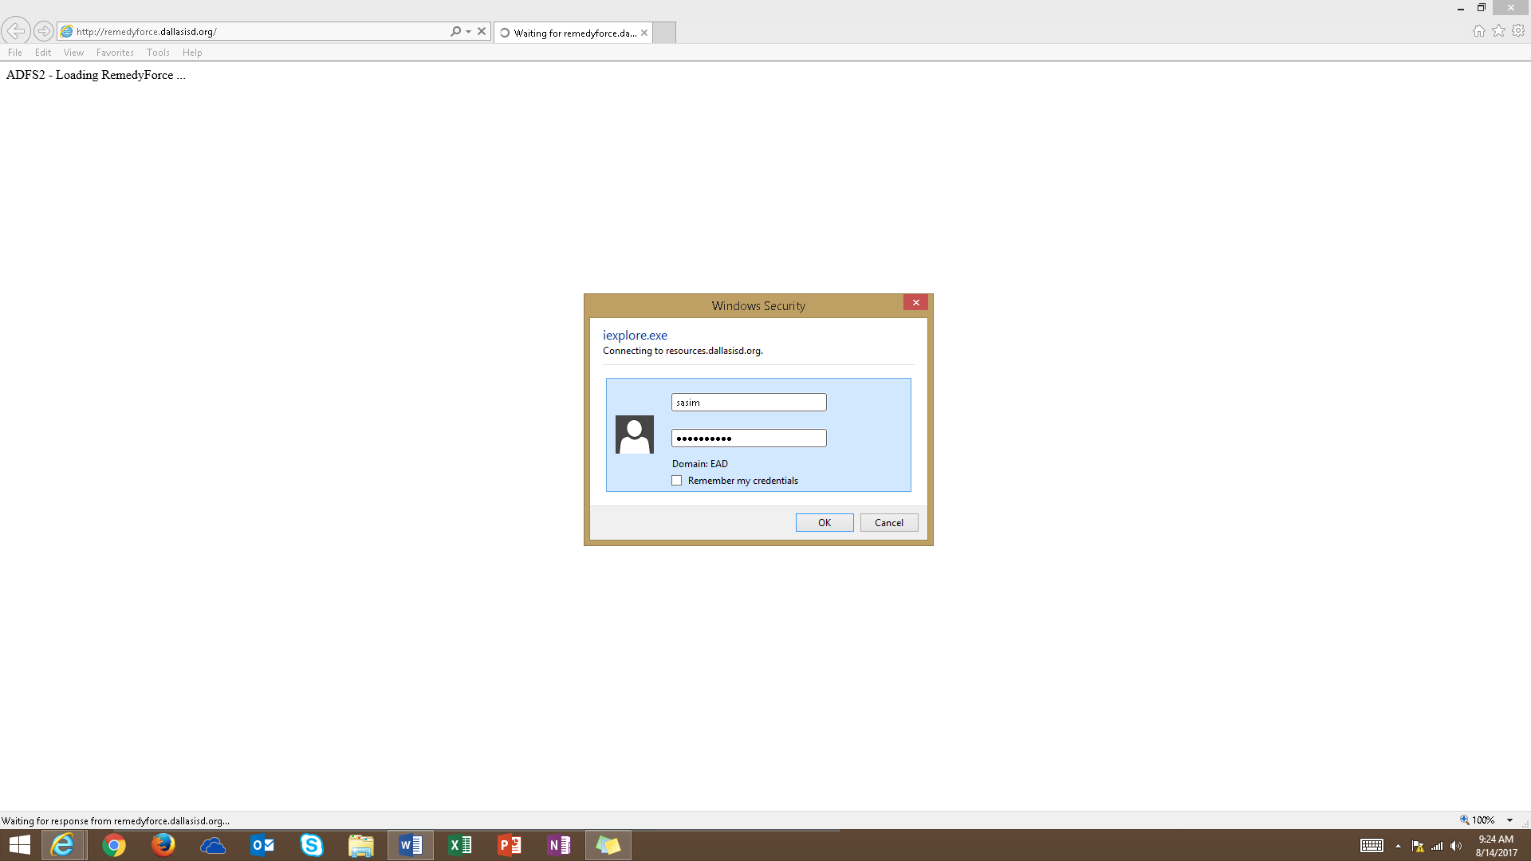
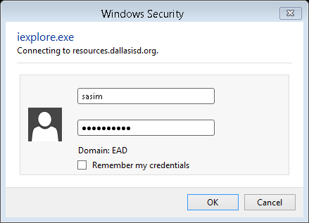
- Sign in with your EAD Username and Password.
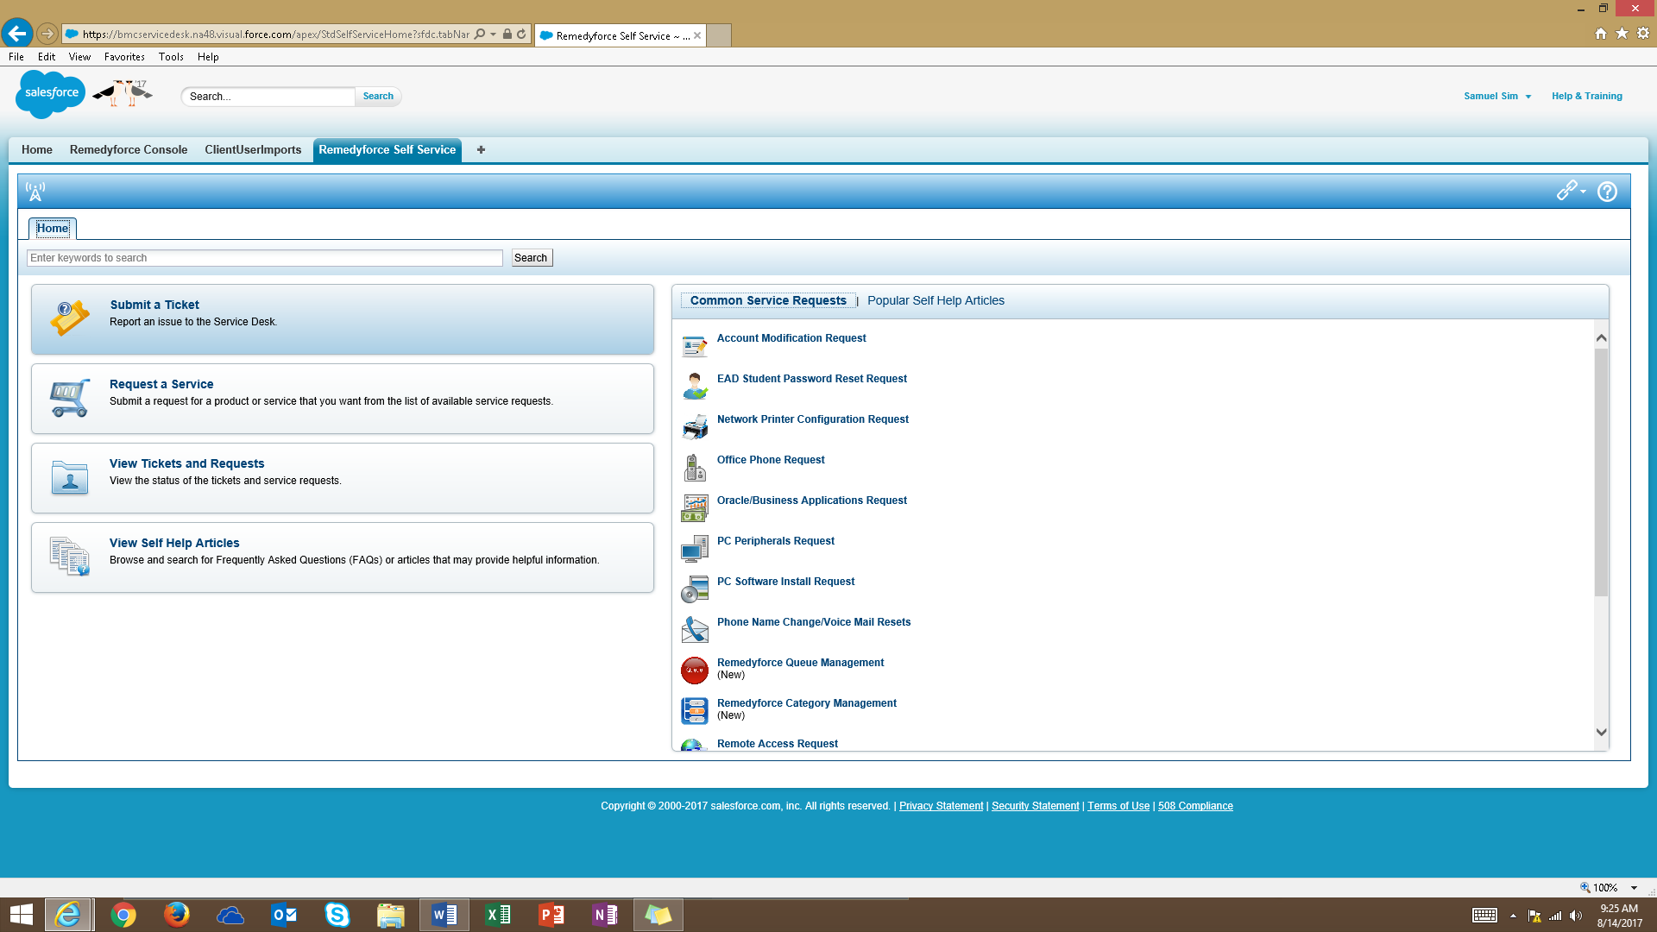
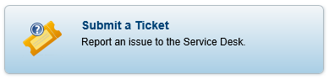
- Click on Submit a Ticket.

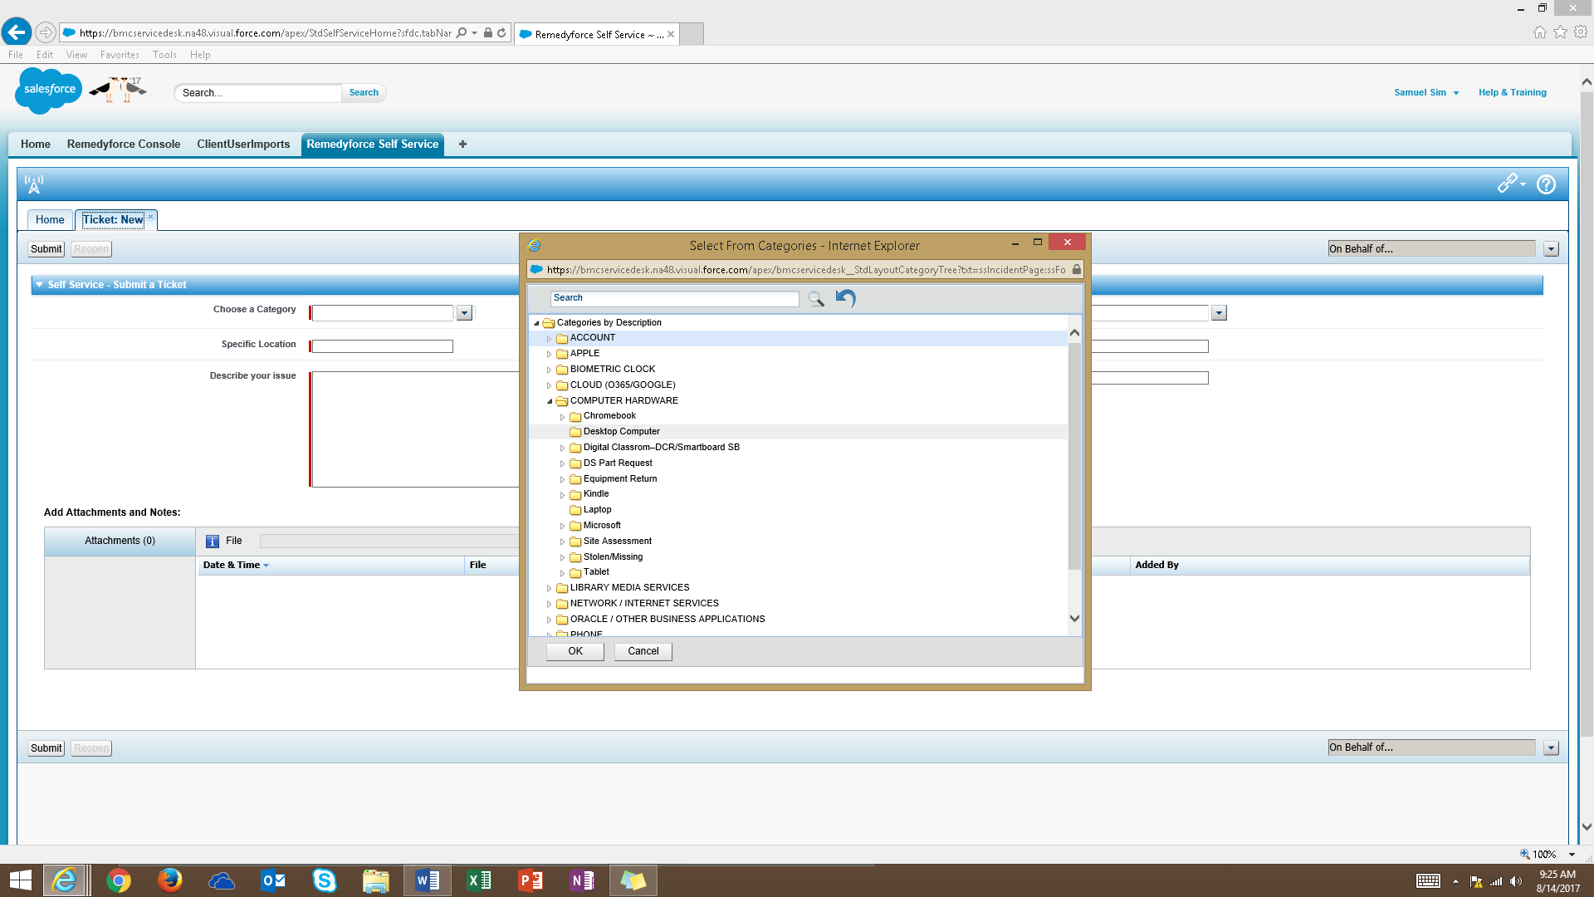
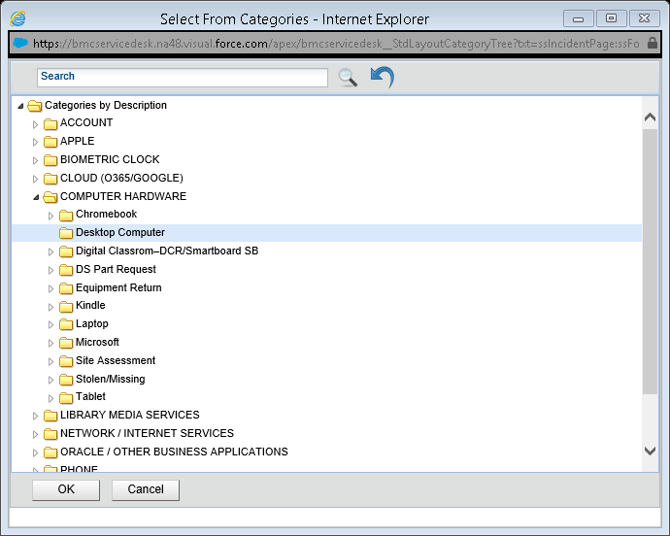
- Fill out all the RED line
  - Choose a Category click on the drop down you will see a list of category.
  - Specific Location your school name.
  - Describe your issue describe your issue of the technology you are having.
  - Contact # your contact number.
  - Room/Office Room # or office location.
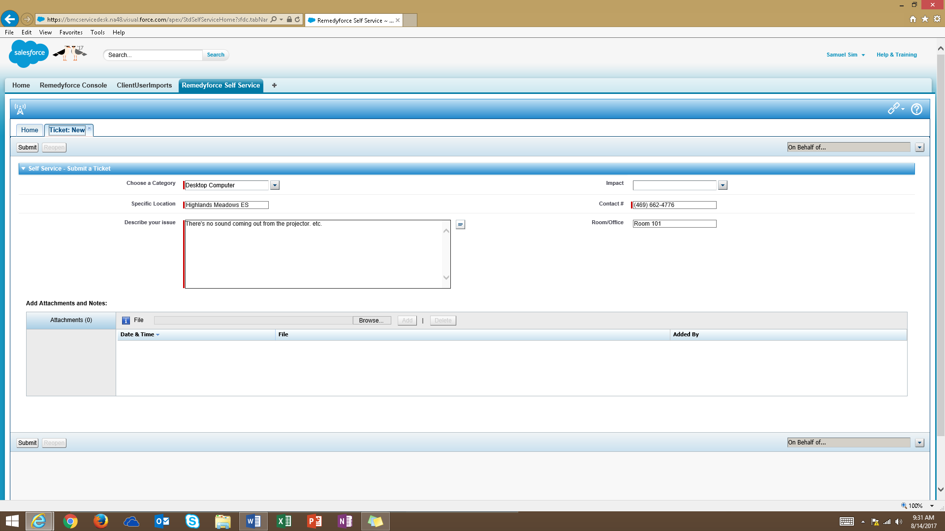

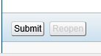
- Click on Submit

